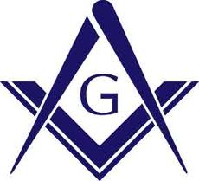**Lake Drummond Lodge No. 178, A.F. & A. M.**

CHARTERED DECEMBER 16, 1874

STATED COMMUNICATION SECOND THURSDAY OF EACH MONTH

P.O. BOX 6655, Chesapeake, VA 23323-0655

Kyle W. Strickland

Secretary

757-754-1671

178secretary@gmail.com

Dennis L. Bagley

Worshipful Master

757-295-6990

dennisbagley178@gmail.com

February 1, 2017

To whom it may concern:

Lake Drummond Lodge No. 178 will hold its eight Annual Golf Tournament on Friday, October 6, 2017 at 12:30 PM at Riverfront Golf Club in Suffolk, VA.

This fundraiser will benefit our Scholarship Fund only. Lake Drummond this year awarded scholarships totaling $2,000.00 to deserving high school seniors, the amount of funds raised will help ensure scholarships are available for future outstanding students. Lake Drummond Lodge cares deeply about our next generation. These young people are our future and we must aide and assist them in every way possible. Charity is one of the most important aspects of Masonry and our Scholarship Fund allows us to contribute to the next generation of communities.

As an important member of the Hampton Roads community, you have an opportunity to make a difference in your community. We are offering sponsorship opportunities to our local business leaders. We have multiple levels of sponsorship; every donation is appreciated. The Beverage Sponsor, costing 500 dollars, hole sponsorship, at 100 dollars, are some of the popular sponsor levels. There will also be a 19th hole sponsor for 1,000 dollars. This sponsor level includes a four-person team, sign on the 18th hole, banner at awards presentation, and a special plaque.

In addition to sponsorships, donations for door prizes and raffles are sought after. These prizes make their way to numerous potential consumers and will be accompanied with a card from the store or business who donated it to encourage patronage. Also, the golf tournament will be open to all entries. The entry fee is $300.00 per four-person team, and will cover the green fees, a cart, goodie bag, raffle ticket and dinner afterwards.

Please contribute to this worthwhile Fundraiser, help support Lake Drummond Lodge and in turn the Community that we all live and love.

Contact Chris Turner at 757-876-2212 for further information or to register a team. Thank you for your support and I look forward to seeing you on the golf course.

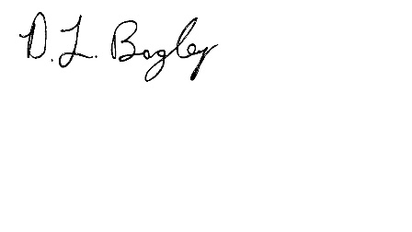

Sincerely,

Dennis L. Bagley

Worshipful Master

Lake Drummond Lodge No. 178